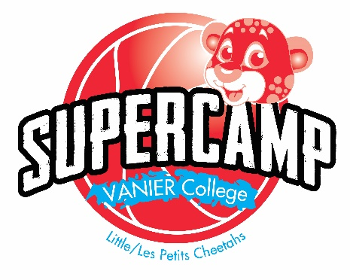
Refund Request

Summer 2017

Your refund request must be done in writing and signed, or sent by email to
supercamp@vaniercollege.qc.ca.

- We will only refund entire weeks.
- To receive your refund, you must make the request 10 days in advance of the beginning of the week you are cancelling.
- Your refund will be sent by cheque, after a processing time of 30 days.
- A 10 percent administrative fee will be charged for all cancellations.

Name of registered camper :

I wish to cancel my child’s registration from the following program :

Week of the 26th to 30th June | Name of the program: |  | Extended supervision hours/swimming lessons
Week of the 3th to the 7th of July | Name of the program: |  | Extended supervision hours/swimming lessons
Week of the 10th to the 14th  of July | Name of the program: |  | Extended supervision hours/swimming lessons
Week of the 17th to the 21nd  of July | Name of the program: |  | Extended supervision hours/swimming lessons
Week of the 24th to the 28th  of July | Name of the program: |  | Extended supervision hours/swimming lessons
Week of the 31st of July to the 4th of  August | Name of the program: |  | Extended supervision hours/swimming lessons
Week of the 7th to the 11th of  August | Name of the program: |  | Extended supervision hours/swimming lessons
Week of the 14th to the 18th of  August | Name of the program: |  | Extended supervision hours/swimming lessons

Name of the person to whom the cheque will be addressed :

Phone number :

Date : ____________________________ Signature :______________________________________________

Reserved for Administration

Received by : ___________ Date : ___________ Sent an email Left a voicemail

Processed by : ___________ Date : ___________

Calculation :

